Kameron Eves

Midterm 2 Part 2 Results

Note that because no saturation limits were given, I cranked up (or I guess technically down) the rise time to get a very fast response. A real system would be limited by its saturation limits and so my rise time might have to be higher.

Plots:

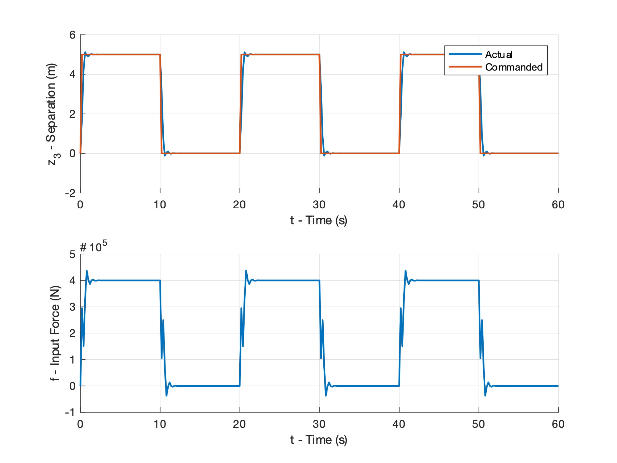

Gain values:

$$K=[-1.5798*{10}^{5}, 1.0531*{10}^{5}, -6.4624*{10}^{3}, 1.0757*{10}^{4}]$$

$$k_{r}=1.9360*{10}^{4}$$